Chapter 15
Predictive Model of Personalized Recommender System of Users Purchase
Darshana Desai^{1*}
¹Dept. of MCA, Indira College of Engineering and Management, Pune, India

ABSTRACT

Real-time personalization is adopted by e-commerce websites to leverage business opportunity with the offering recommendation which caters users’ implicit need, but little is known about its effect on users' privacy concerns and trust towards purchase behavior. This research develops a predictive model exploring the effect of personalization on users' trust and privacy concerns towards personalization and interrelation with the willingness to purchase with the e-commerce site. SEM is used to develop a model after EFA and CFA results. The result shows the model fit which of personalization and role of personalized information relevance towards the belief of trust and privacy concerns in e-commerce websites. Our findings suggest that: personalized recommendation is positively associated with users’ satisfaction and privacy concerns. Result shows that users trust is not associated with the privacy concerns, users experience less trust with high privacy concerns. Users with higher satisfaction with ecommerce websites are likely to develop more trust, although users purchase intention is not affected by satisfaction but it positively affects purchase intention if privacy concerns of the users are addressed in personalized recommendation.

Keyword: Predictive Model, Personalized Recommendation, Privacy Concerns, Trust, Satisfaction, Purchase Intentions, Collaborative Filtering
- Introduction
Personalized Recommendation is used as an effective instrument to moderate the cognitive load of users on cybernetic markets on e-commerce websites with suggesting information about product, or services. Users' personal information, purchase behaviors, preferences, geo-location search and website trail are monitored and stored with latest information about the users to serve them better, by e-commerce sites. Real-time personalized recommendations are presented by understanding implicit tastes, surfing of websites, behavioral intents like time spent on the page, no. of the visit to pages, frequency of item viewed, search and purchase history with now and current data analytics. Continuous monitoring of the user's activities in order to create personalized recommendations and suggest highly relevant content, users’ detailed information is fetched on a real-time basis upon constant monitoring of users' activities which have raised privacy concerns and trust issues in e-commerce websites. Identification of users' personality traits and Also all these activities fuel data breaching which may lead to high privacy concerns, reduction in trust amongst users, and affect their purchase decisions. The personalization process needs more data with monitoring users' activities with the right context to generate highly relevant personalized recommendations. Users experience more privacy concerns with tracking of their activities and interaction. Different privacy policy is introduced to regulate the business process, data acquisition and its usage for commercial or other purpose including Do-Not-Track initiative and limiting data collection by providing users control for data collection which have reduced privacy concerns in users (Ghahtarani 2020, Mayer and Narayanan 2011, Wang and Kobsa 2007).
Highly personalized recommendation and user behavioral tracking have raised more concerns towards privacy and security concerns. Recently users’ privacy concerns have increased to prominently develop trust before purchasing on e-commerce websites. Personalization strategies have been used extensively over a decade to lower cognitive load on the user and influence for high returns in business but little is focused on customer data privacy and their concerns on information disclosure. Though users’ satisfaction and cognitive behavior with personalized information is researched towards its effect on purchase intentions (Desai 2019), studies have shown a deficit in addressing the issue of impact of personalized recommendations on users purchase intention through intrinsic feeling of trust and privacy concerns. In this view to address the research gap, our research explores personalized recommendations used in e-commerce website Amazon.com on users' purchase behavior through privacy concerns and trust in the website. The research will provide a roadmap for business to use personalization features while considering privacy concerns and trust issues with personalized contents. The paper is organized as follows: Section 2 describes related work in the context of personalized recommendation, trust, privacy concerns, satisfaction, and its effect on purchase behavior. Section 3 represents hypotheses; section 4 describes the research methodology adopted to address the research question and analysis using Exploratory Factor Analysis and Confirmatory Factor Analysis. The section also shows results of model validity and SEM Model Subsequently, section 5 presents the result analysis, with hypothesis testing results and Discussion. Finally, section 6 represents findings and future scope of research.
2. Related Work

Personalized Recommendation produced in e-commerce websites on a real-time basis, is a continuous process addressing users' requirements with highly relevant information (Desai 2021, Desai 2019). The user's needs are identified implicitly by analyzing search history, website clicks, purchase history, demographics, likings and explicitly producing customization options and choices of filters.(Desai 2015; Taylor et al. 2015;Chellappa and Sin 2005; Liang et al. 2007). Research suggests that recommendation services reduce users' cognitive load producing ease of use, perceived usefulness, and enjoy the shopping experience, subsequently leading to positive behavior of purchase and revisit to the e-commerce websites (Desai 2016, Liang et al. 2012, Mahrous 2012). Users experience higher satisfaction, more trust with greater interaction with an e-commerce website, show positive behavioral intention and purchase (Dabholkar et al. 2012, Desai 2019). On the contrary, users experience higher privacy concerns and lower satisfaction with the recommendation associated with higher financial risks (Stevenson 2015, Barth 2017). Research also suggests that recommendations of sensitive products generate higher privacy concerns in the user and are likely to experience lower trust in the e-commerce websites affecting negatively in behavioral intentions like revisit and purchase.

Personalized recommendation systems adopt different approaches and techniques to learn about users' preferences through analyzing users’ behavioral data like collaborative filtering, user profiling, content-based and hybrid model-based recommendation (Zhang et al. 2019, Desai 2015). Research has found significant performance improvement in business and customer experience with the personalized recommendation in e-commerce websites like Amazon.com use collaborative filtering technique to generate product recommendation by analyzing like-minded people purchase behavior and suggesting related items which are bought frequently together (Koustan and Riedl 2012, Pu et al. 2011)

Frequent interaction with the e-commerce websites and increased use of recommendation services produce increased satisfaction, higher trust, and greater purchase intentions. However trust in the recommendation is strongly associated with the users desire to avail personalization services (Dabholkar et al. 2012) and higher relevance of personalized recommendation to users implicit need and accuracy of recommendation induce more satisfaction in users instigating positive behavioral intentions like revisiting to the website and purchase(Desai 2019, Desai 2016, Stevenson 2015, Liang et al. 2007)
3. Research Hypotheses
Research in personalization has shown a significant relation between information personalization and users' intention to revisit the website. Our research framework proposes interrelation of personalized recommendation, privacy concerns, trust, satisfaction, and behavioral intention of user-like purchase in e-commerce websites.
3.1 Personalized Recommendation, Privacy Concerns

To provide personalized content, applications require users personal information ( Gupta et al 2015; Shin et al 2010) and understand users implicit need by observing interaction with the website(Desai 2015) purchase behavior, likings has the potential for an invasion of privacy. Individuals might have higher privacy concerns about online personalization if they are not aware of the intentions behind content personalization which reduces trust in social networking sites. Users experience higher privacy concerns when the personalization process uses users’ information without consent and have negative feelings about personalization.

H1: User exhibits more privacy concerns with higher personalized recommendation.
3.2 Personalized Recommendation and Satisfaction
Users experience higher satisfaction with highly relevant personalized information, perceived ease of use, and usefulness of the recommendation. Explicit personalization or customization choices offered to users produces a sense of control and involvement in the personalization process which lead to higher satisfaction and joyful interaction with personalized e-commerce sites (Desai 2019). So our work hypothesizes:
H2: User experience satisfaction is positively associated with personalized recommendations.

3.3 Privacy Concern and Trust

Personalization of websites reduces cognitive efforts by the user to search information and users feel higher satisfaction with more relevant personalized information (Desai 2019, Desai 2022) eventually developing trust towards websites. Users with higher privacy concerns need more control over personalization to develop trust over social networking websites (Desai 2021). Privacy concerns of the user lead to trust-building upon fulfillment. Personalized recommendation generates cognitive benefits to users at the cost of information disclosure. In the process to achieve personalization, websites need to collect more information about users’ personal and behavioral characteristics like interests and implicit needs. This increases privacy concerns when privacy risks are associated particularly in wary of personalized content (Stevenson et. al. 2015). So Research postulates:

H3: Users exhibit higher trust with addressed privacy concerns.

3.4 Privacy Concerns and purchase intention

Privacy concern is the user's inbuilt desire for controlling the procurement and information usage upon sharing or acquired through website interaction and transactions. Privacy concerns of the user are related to the user's anonymity preservation and are strongly associated with the control of the user on personalization, explicit customization through settings and preferences. Earlier research has found that information control is a major factor in the privacy concerns of the user in an online environment (Sheehan Hoy 1999). Users have high privacy concerns when perceived with high risk and threats to privacy upon information sharing and less control over personalization settings like users will have less concern about privacy when provided with the option to control the visibility of posted content. In contrast, users experience lower privacy risks provided with higher control with exposure to privacy policies and sharing personal information (Mohamed et. al. 2012). So researcher postulates:

H4: Users' purchase intention is associated with privacy concerns.

3.5 Satisfaction, Trust and purchase intention

Trust is users’ intrinsic feeling and willingness to be vulnerable to the actions with expectation and addressed their expectations (Yerizal 2021, Dwyer 2007). Users having control over information flow, profile visibility, and protection of their personal information are more likely to develop higher satisfaction and trust in e-commerce websites. Highly relevant personalized content offering on websites like a targeted advertisement, recommendation, location tracking, and offering suggestions based on Geographic’s increased users’ satisfaction induces intrinsic feeling trust which motivates users for purchase. So, we propose:

H5: Users experience more trust with higher satisfaction.

H6: Users' purchase intention is highly associated with users' Trust.

H7: Users purchase intention is highly associated with users Satisfaction

4. Research Methodology

4.1 Data Collection and Sampling

Research provide predictive model of users purchase intention on Amazon.in e-commerce website who are using this site for more than two years. The data was collected based on real purchase of the users on the amazon.in site. The constructs were identified from the prior studies are personalized recommendation, trust, privacy concerns, satisfaction, and purchase intention, and are measured with a five-point Likert scale.
Table 1: Sample demographics
Measure | Item | Frequency
Gender | Male | 328
 | Female | 172
Age (years) | 18–25 | 392
 | 26–35 | 68
 | 36–50 | 38
 | >50 | 2
Education | Undergraduate | 183
 | Graduate degree | 120
 | Post Graduate | 195
 | Doctorate | 2
Occupation | Student | 363
 | Service | 106
 | Self-employment | 12
 | Homemakers/Retired | 19
Experienced | Directly | 428
Personalization | Indirectly | 72

4.2 Data Analysis & Measurement Model

The reliability of the constructs was checked through a pilot study of 50 responses to confirm the validity of variables and survey questions. The population of data collection is the respondents from India who have purchased online on Amazon.in e-commerce websites and have experienced personalization in the form of the personalized recommendation of product, service, or information directly or indirectly. 441 valid responses were collected from a total of 500 responses through data preprocessing. Data cleaning was done after the removal of noisy, incomplete, and inconsistent data. Responses with a standard deviation below .30 were removed to fetch final valid responses for further data analysis. Factors were identified and confirmed using Exploratory & Confirmatory Factor Analysis methods using SPSS 20.0. The structural Equation Modeling (SEM) technique is used to identify the model fit of the proposed model.
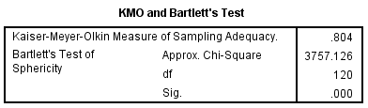
Figure 1: KMO Bartlett Test Result
KMO and Bartlett’s test result value 0.804 which is above 0.7 shows sample size adequacy of data collection,Exploratory Factor Analysis techniques discovered 5 factors named personalized recommendation, trust, privacy concerns, satisfaction, and purchase intentions through extraction method Maximum Likelihood. Figure 2 below shows 5 factors with 61.312% of the cumulative load.
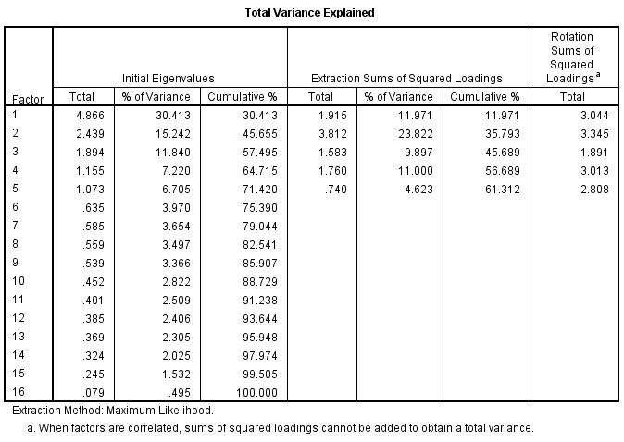
Figure 2: Total Variance

The Cronbach’s Alpha coefficient values of construct items were observed in the range of 0.70`0.90 showing higher internal consistency of constructs and consistency of scale of questionnaire items. Construct items Factor loading values were identified above 0.5 in Figure 3, showing satisfactory factor loading with higher construct validity and reliability.
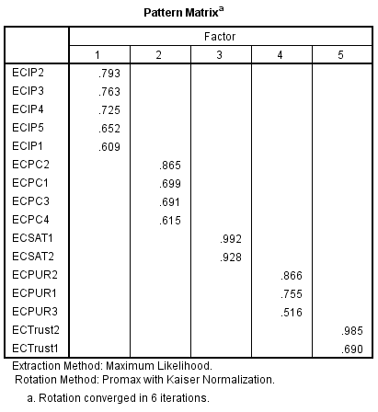
Figure 3: Pattern Matrix

Figure 4: below shows the factor correlation matrix shows the interrelation of the factors identified after EFA.
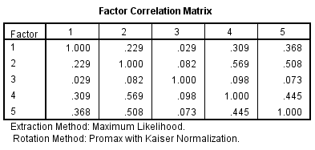
Figure 4: Factor Correlation Matrix

  - Confirmatory Factor Analysis and Validity Test
Conﬁrmatory factor analysis is used to test the measurement model using SPSS AMOS 21.0. Model fit is proved if the model-fit indices reach accepted standards and recommended values, the result shown in the table exhibits adequate fit as the model fit index exceeds the recommended value.

Composite Reliability measure shows internal consistency of construct item, CR value is above 0.7 indicating good reliability and measurement items stability of each construct. Every CR scored above 0.8, which is above the recommended value by Fornell and Larcker (1981), indicating good reliability and stability for the measurement items of each construct.

Convergent Validity of measurement model standards recommended by Bagozzi and Yi (1988) as: (1) factor loadings of the construct should exceed 0.5 (Hair et al., 1998); (2) Composite Reliability (CR) should be above 0.7; and (3) Average Variance Extracted (AVE) score of each construct should exceed 0.5 (Fornell&Larcker, 1981). The result shown in Table 2 depicts the factor loading score of each construct item exceeded 0.7, CR of the construct is above 0.7, and AVE score ranges from 0.50 to 0.96 which satisfies all the conditions for convergent validity showing measurement items correlates strongly with its theoretical constructs.

Table 2: CR, AVE & Discriminant Validity
 | Composite ReliabilityCR | Average Variance Extracted AVE | Purchase_  Intention | Personalized_  Recommendation | Privacy_  Concerns | Satisfaction | Trust
Purchase_  Intention | 0.788 | 0.555 | 0.745
Personalized_  Recommendation | 0.836 | 0.507 | 0.311 | 0.712
Privacy_Concerns | 0.821 | 0.534 | 0.612 | 0.235 | 0.731
Satisfaction | 0.984 | 0.969 | 0.096 | 0.027 | 0.064 | 0.984
Trust | 0.834 | 0.715 | 0.505 | 0.385 | 0.540 | 0.068 | 0.846

Fornell and Larcker (1981) suggested that for the discriminant validity of the model, the AVE of the construct should exceed the correlation coefﬁcients of the constructs. Table 2 shows the correlation coefficient matrix of all the constructs in the research model, diagonal element values are square roots of the AVE score for the constructs. The correlation coefficient values for any two constructs are lesser than the square root of the AVE score for the constructs. Research shows good discriminant validity of the research constructs in model measurement as constructs are different from each other. Research results show that the measurement model is having good construct reliability, discriminant validity, and convergent validity.

Structural Equation Modeling

Research model is tested with a structural Equation model using AMOS 21.0. The model fit indices v2/df = 1.772, GFI = 0.961 AGFI = 0.94, NFI = 0.95, CFI = 0.98, RMSEA = 0.039 were achieved in result indicates good model All the indices for model fit in structural equation modeling indicates that is proposed model have good fit.
Figure 5 displays the standardized path coefficients, variance explained (R²) and path significance values for the path as per the proposed hypothesis, and all hypotheses are supported except correlation of trust and satisfaction. As with variance explained (R²), R² values of purchase intentions and Trust are 0.32 and 0.46 which is above 0.3 shows a good research model.
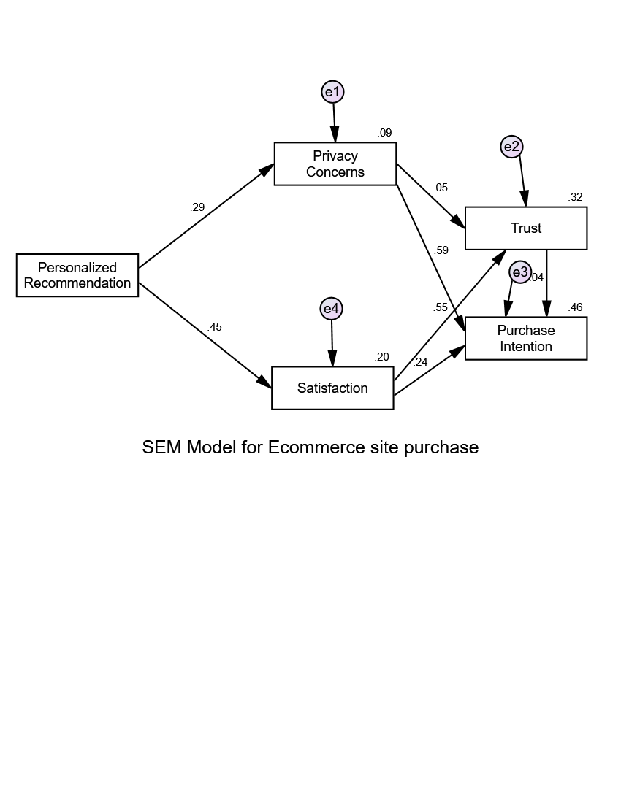

Figure 5: Structural Equation Modeling Result

- Result & Discussion:

SEM result in table 3 shows that users experience higher privacy concerns with the increase in personalized recommendations and feel satisfied with the highly relevant recommendations which address their needs. Research results show that users’ trust is not affected by privacy concerns but it is highly related with the satisfaction with the personalized recommendations. Users' purchase behavior with ecommerce websites depends on privacy concerns and trust with the site. Users are likely to purchase if users’ privacy concerns are addressed properly while offering personalized recommendations. The result also shows the willingness of the user to purchase is not affected by Satisfaction.

Table 3: Hypotheses Testing Result

Hypotheses |  |  | Estimate | S.E | C.R. | P- Value
H1: Privacy_Concern | <--- | Personalized Recommendation | .296 | .043 | 6.835 | ***
H2: Satisfaction | <--- | Personalized Recommendation | .493 | .044 | 11.246 | ***
H3: Trust | <--- | Privacy_Concern | .076 | .054 | 1.406 | .160
H4: Trust | <--- | Satisfaction | .740 | .050 | 14.826 | ***
H5: Purchase | <--- | Trust | .246 | .040 | 6.129 | ***
H6: Purchase | <--- | Privacy_Concern | .646 | .036 | 17.809 | ***
H7: Purchase | <--- | Satisfaction | .027 | .030 | .890 | .373
*** indicates p value < 0.001

- Conclusions & Future Scope of Research:
Users’ privacy concerns and satisfaction in ecommerce websites personalized recommendation plays a significant role in developing trust and positive behavioral intention to purchase with the e-commerce website. Personalized recommendations on ecommerce websites lead to higher satisfaction in case of users' implicit needs are satisfied with the high relevance with expectation. On the other hand it may lead to high privacy concerns if recommendations are not addressed properly. Users' purchase intention is affected by privacy concerns and users' satisfaction with the personalized recommendations lead to trust development towards the site resulting in positive purchase intentions. Result shows that personalized recommendation is positively associated with users’ satisfaction and privacy concerns. Users experience lesser trust towards websites with high privacy concerns but the result shows that users' purchase intentions are not affected by satisfaction but are positively affected by trust and privacy concerns.
This research is a qualitative study on users’ purchase intention in Amazon.in on an e-commerce website. The survey-based research methodology adopted for the study which can be further researched with users purchase intention in a controlled lab environment. Research can be further enhanced with the personalized recommendations attributes and focus on deep insight of optimization of recommendations with high relevance based on the real-time analytics of the users’ interactions and search. Real-time predictive analytics model can be further proposed to address users’ dynamic need in future in considering structured as well as unstructured data.

References:

- Bagozzi, R.P., Yi, Y. (1988). On the evaluation of structural equation models. JAMS 16, 74–94 https://doi.org/10.1007/BF02723327
- Barth, S., & de Jong, M. D. T. (2017). The privacy paradox – Investigating discrepancies between expressed privacy concerns and actual online behavior – A systematic literature review. In Telematics and Informatics (Vol. 34, Issue 7, pp. 1038–1058). Elsevier Ltd. https://doi.org/10.1016/j.tele.2017.04.013
- Chellappa, R.K., Sin, R.G. (2005). Personalization versus Privacy: An Empirical Examination of the Online Consumer’s Dilemma. Information Technology Manage 6, 181–202 https://doi.org/10.1007/s10799-005-5879-y
- Dabholkar, P. a., & Sheng, X. (2012). Consumer participation in using online recommendation agents: effects on satisfaction, trust, and purchase intentions. The Service Industries Journal, 32(9), 1433–1449. https://doi.org/10.1080/02642069.2011.624596
- Desai D. (2021) Role of Privacy Concern and Control to Build Trust in Personalized Social Networking Sites. In: Sheth A., Sinhal A., Shrivastava A., Pandey A.K. (eds) Intelligent Systems. Algorithms for Intelligent Systems. Springer, Singapore. https://doi.org/10.1007/978-981-16-2248-9_10 (Scopus Indexed)
- Desai D. (2019) "Personalization Aspects Affecting Users’ Intention to Revisit Social Networking Site" Published in International Journal of Trend in Scientific Research and Development (ijtsrd), ISSN: 2456-6470, Volume-4 | Issue-1, December, pp.612-621 URL: www.ijtsrd.com/papers/ijtsrd29631.pdf
- Desai D. (2018) An Empirical Study of Website Personalization Effect on Users Intention to Revisit E-commerce Website through Cognitive and Hedonic Experience. In: Balas V., Sharma N., Chakrabarti A. (eds) Data Management, Analytics, and Innovation. Advances in Intelligent Systems and Computing, vol 839. Springer. https://doi.org/10.1007/978-981-13-1274-8_1
- Desai D. Kumar S. (2015). “Web Personalization: A perspective of design and implementation strategies in Websites“ Khoj: Journal of Management Research & Practices,109-119 ISSN No: 0976-8262.
- Desai D.(2016). “A study of personalization effect on users’ satisfaction with ecommerce Websites” Sankalpa- Journal of Management & Research" Volume 6, Issue 2, 51-62 ISSN No. 2231-1904.
- Desai, D. (2022). Hyper-Personalization: An AI-Enabled Personalization for Customer-Centric Marketing. In Adoption and Implementation of AI in Customer Relationship Management (pp. 40-53). IGI Global.
- Dwyer, C., Hiltz, S. R. and Passerini, K. (2007) ‘Trust and privacy concerns within social networking sites: A comparison of Facebook and MySpace’, Americas Conference on Information Systems, Proceedings of the Thirteenth Americas Conference on Information Systems, Keystone, 9–12 August, Colorado, USA, p. 339. https://aisel.aisnet.org/amcis2007/339
- Fornell, C., &Larcker, D. (1981). Evaluating Structural Equation Models with Unobservable Variables and Measurement Error. Journal of Marketing Research, 18(1), 39-50. doi:10.2307/3151312
- Ghahtarani, A., Sheikhmohammady, M., &Rostami, M. (2020). The impact of social capital and social interaction on customers’ purchase intention, considering knowledge sharing in social commerce context. Journal of Innovation and Knowledge, 5(3), 191–199. https://doi.org/10.1016/j.jik.2019.08.004
- Gupta, A., &Dhami, A. (2015). Measuring the impact of security, trust, and privacy in information sharing: A study on social networking sites. Journal of Direct, Data and Digital Marketing Practice, 17(1), 43–53. https://doi.org/10.1057/dddmp.2015.32
- Konstan, J. A., Riedl, J., Konstan, J. A., &Riedl, J. (2012). Recommender systems: from algorithms to user experience. 22, 101–123. https://doi.org/10.1007/s11257-011-9112-x
- Liang, T.-P., Chen, H.-Y., Du, T., Turban, E., & Li, Y. (2012). Effect of Personalization on the Perceived Usefulness of Online Customer Services: a Dual-Core Theory. Journal of Electronic Commerce Research, 13(4), 275–288. http://www.ecrc.nsysu.edu.tw/liang/paper/2/79 Effect of Personalization on the Perceived (JECR, 2012).pdf
- Mahrous, A. A. (2011). Antecedents of privacy concerns and their online actual purchase consequences: a cross-country comparison. In Int. J. Electronic Marketing and Retailing Vol. 4, Issue 4
- Mayer, J.R., Narayanan, A.(2011) Do not track iab/w3c/ietf position paper. Tech. rep., W3C
- Mohamed, N. and Ahmad, I. H. (2012)‘ Information privacy concerns, antecedents and privacy measure use in social networking sites: Evidence from Malaysia, Computers in Human Behavior, Vol. 28, No. 6, pp. 2366–2375 DOI: https://doi.org/10.1016/j.chb.2012.07.008
- Pu P, Chen L, and Hu R (2011) A User-Centric Evaluation Framework for Recommender Systems. Proceedings of the Fifth ACM Conference on Recommender Systems (ACM), 157-164.
- Sheehan, K.B., Hoy, M.G. (1999). “Flaming, Complaining, Abstaining: How Online Users Respond to Privacy Concerns”, Journal of Advertising, (28), 3: 37-51.
- Shin, D.(2010) The effects of trust, security, and privacy in social networking: A security-based approach to understand the pattern of adoption, Interacting with Computers,22(5),.428-438 https://doi.org/10.1016/j.intcom.2010.05.001
- Stevenson, Darren, and Pasek(2015). Privacy Concern, Trust, and Desire for Content Personalization The 43rd Research Conference on Communication, Information and Internet Policy. http://dx.doi.org/10.2139/ssrn.2587541
- Sutanto, J., Palme, E., Tan, C., &Phang, C. (2013). Addressing the Personalization-Privacy Paradox: An Empirical Assessment from a Field Experiment on Smartphone Users. MIS Quarterly, 37(4), 1141-1164. Retrieved March 5, 2021, from http://www.jstor.org/stable/43825785
- Taylor, D.G., Davis, D., &Jillapalli, R. (2009). Privacy concern and online personalization: The moderating effects of information control and compensation. Electronic Commerce Research, 9, 203-223. DOI:10.1007/s10660-009-9036-2
- Wang, Y., Kobsa, A.(2007): Respecting users’ individual privacy constraints in web personalization. In: Conati,C., McCoy, K., Paliouras, G. (eds.) UM07, 11th international conference on user modeling, Berlin– Heidelberg–New York, pp. 157–166. Springer-Verlag, Corfu
- Yerizal, Y., &Abror, A. (2019). The Influence of E-Wom and Image Destination on Revisit Decision Moderated by Trust: A Literature Review. https://doi.org/10.2991/piceeba2-18.2019.58
- Zhang S, Yao L, Sun A, and Tay Y. (2019) Deep Learning Based Recommender System: A Survey and New Perspectives. ACM Computing Surveys (CSUR) 52(1): 1-38.

Abstract. Abstract goes here.
Keywords..
- Heading
Text goes here.
- Heading
Text goes here.
.
References

